Our IVF Team

Successful fertility treatment is all about teamwork. From the first consultation right through to the treatment process and afterwards, an experienced, highly skilled and committed team is here to ensure the best possible advice, treatment and care.

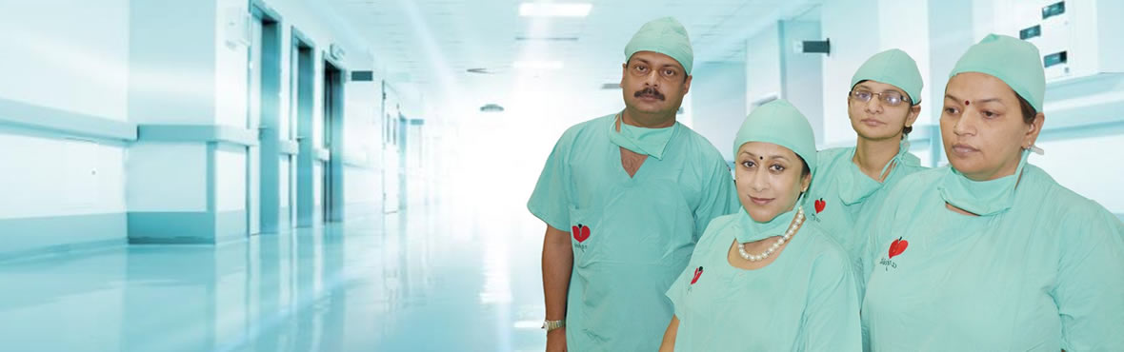

Arpit Test Tube Baby Centre is fully-equipped, with its own surgical and day care facilities. Experienced and highly-qualified staff works in a friendly, relaxed and stress-free atmosphere.

Everything we do is dedicated to one single objective - successful treatment. Everyone at Arpit Test Tube Baby Centre is committed to your success.

Late Dr. A. K. Bansal

**M.B.B.S., MS, FAIS, FCGP, FIAGES**  
Founder

Dr. Vandana Bansal

**MS, D.Phil (Gold Medalist), DGO, FCGP**  
Director

Dr. Arpit Bansal

**MBBS, MS, FMAS, FCS**  
Director

Dr. Hrishikesh Pai

**MD, FCPS**  
Visiting IVF specialist

Dr. Santosh Kumar Singh

**MD (Radiologist)**

Dr Sachin Manjerekar

**Embryologist**  
Visisting Embryologist

Mr. Saugat Bose

**M.Sc. (Biochemistry)**  
Embryologist

Dr. Anjula Sahai

**MBBS, DGO, FCPS**  
IVF Counselor

Mrs. Pooja Bansal

Embryologist & IVF Counselor

Mrs. Mamta Tiwari

**M.Sc. (Medical Micro Biology)**  
IVF Counselor